🏨 Business Problem Statements
- High Cancellation Rate Hotels face significant booking cancellations, impacting revenue and resource planning.
- Country-wise Guest Behavior Different countries show varying booking and cancellation patterns, affecting marketing strategies.
- Guest Demographics Impact Couples, families, and singles cancel at different rates, influencing customer segmentation.
- Seasonality & Monthly Trends Cancellations vary across months, affecting demand forecasting.
- Room Preference & Satisfaction Desired vs. undesired room allocations impact guest satisfaction and repeat bookings.
- Children & Babies in Hotels Family-oriented facilities may influence booking behavior and cancellations.

🔍 Research Questions
1.What is the overall cancellation rate across City vs Resort hotels?
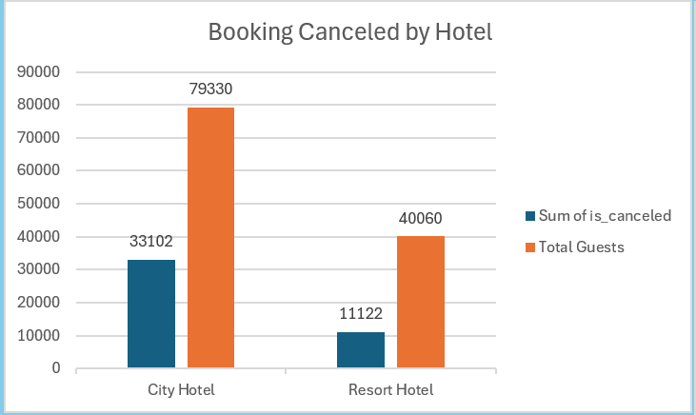
  - City Hotel
- Canceled Bookings: 33,102
- Total Guests: 79,330
- Cancellation Rate: $= 70.6\%$
  - Resort Hotel
- Canceled Bookings: 11,122
- Total Guests: 40,060
- Cancellation Rate: $=78.3\%$
  - Overall (Grand Total)
- Canceled Bookings: 44,224
- Total Guests: 1,19,390
- Overall Cancellation Rate: $37.0\%$

The Tale of Two Hotels
In the bustling heart of the city, the City Hotel stands tall, welcoming business travelers, conference-goers, and short-stay guests. Out of 1,12,432 bookings, nearly 79,330 guests walked away before arrival. That’s a 70.5% cancellation rate. Imagine seven out of every ten reservations vanishing like smoke—yet the hotel still manages to keep its rhythm, because business travelers often rebook quickly or shift dates.
Meanwhile, far from the city’s chaos, nestled among palm trees and ocean breezes, lies the Resort Hotel. Families dream of vacations here, couples plan romantic getaways, and groups envision leisure escapes. But reality bites: out of 51,182 bookings, a staggering 40,060 were canceled. That’s a 78.3% cancellation rate—almost four out of five reservations gone. Leisure travelers, unlike business guests, are more whimsical: plans change, budgets tighten, and holidays get postponed.

- City Hotel: Reliable but still fragile. Cancellations are high, yet business demand cushions the blow.
- Resort Hotel: Riskier, more volatile. Dreams often dissolve before check-in, leaving empty rooms and lost revenue.

2.Which countries contribute most to cancellations and confirmed bookings?
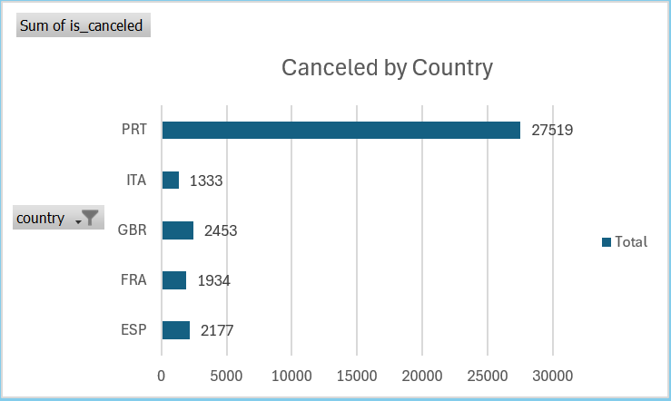
- PRT (Portugal): 27,519 cancellations
- ITA (Italy): 1,333 cancellations
- GBR (United Kingdom): 2,453 cancellations
- FRA (France): 1,934 cancellations
- ESP (Spain): 2,177 cancellations

  - Country-wise Cancellation KPI:
- Portugal: ~62%
- Italy: ~3%
- UK: ~6%
- France: ~4%
- Spain: ~5%

Key Insights
- Portugal dominates cancellations: With 27,519 cancellations, PRT accounts for the overwhelming majority compared to other countries.
- Other countries have relatively low cancellations: Italy, UK, France, and Spain combined (~7,897) are still far below Portugal’s figure.
- Market concentration risk: Heavy reliance on Portuguese guests means cancellations from this market have a disproportionate impact on overall performance.
- Behavioral difference: Guests from Portugal may be more prone to last-minute changes or speculative bookings compared to other European markets.
- Strategic opportunity: Countries like Italy, France, Spain, and UK show lower cancellation volumes, suggesting more stable booking behavior.

3.Do guest types (Couple, Family, Single) show different cancellation patterns?
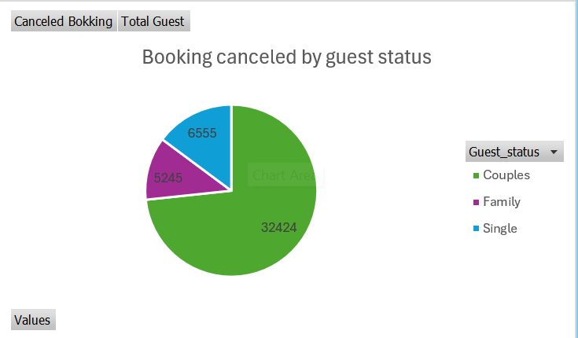
- Couples: 32,424 cancellations
- Family: 5,245 cancellations
- Single: 6,555 cancellations

Key Insights
- Couples dominate cancellations: With 32,424 cancellations, couples account for the majority of canceled bookings.
- Singles show moderate cancellations: At 6,555, single travelers cancel more than families but far less than couples.
- Families are the most reliable segment: Only 5,245 cancellations, suggesting family bookings are more stable and less prone to last-minute changes.
- Behavioral difference:
  - Couples may book more speculative trips (weekend getaways, short leisure stays) and cancel frequently.
  - Families tend to plan longer in advance, making cancellations less likely.
  - Singles show moderate volatility, possibly due to flexible travel plans.

- Guest Type Cancellation % KPI:
  - Couples: 73%
  - Singles: 15%
  - Families: 12%

4.How do monthly cancellations correlate with total guest arrivals?
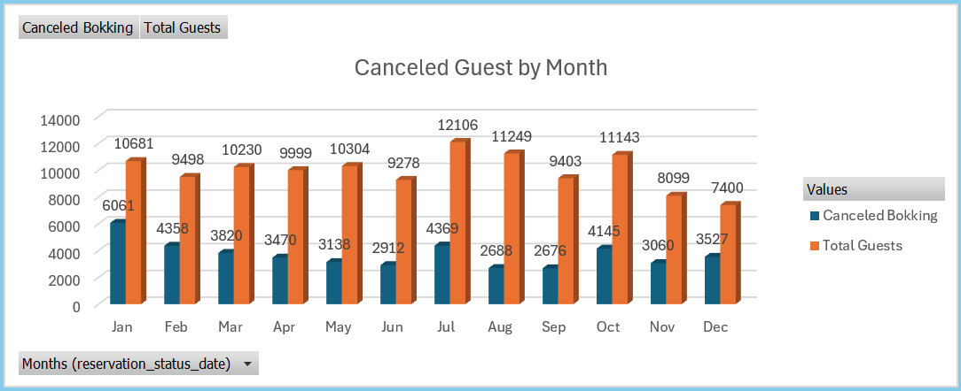
  - Cancelled vs Total Guests
- January: 6,061 / 10,681 → 56.7%
- February: 4,358 / 9,498 → 45.9%
- March: 3,820 / 10,230 → 37.3%
- April: 3,470 / 9,999 → 34.7%
- May: 3,138 / 10,304 → 30.5%
- June: 2,912 / 9,278 → 31.4%
- July: 4,369 / 12,106 → 36.1%
- August: 2,688 / 11,249 → 23.9%
- September: 2,676 / 9,403 → 28.5%
- October: 4,145 / 11,143 → 37.2%
- November: 3,060 / 8,099 → 37.8%
- December: 3,527 / 7,400 → 47.7%
Key Insights
- Peak Cancellation Months:
  - January (56.7%) and December (47.6%) show the highest cancellation rates, possibly due to holiday season uncertainty.
- Stable Months:
  - May–September show lower cancellation rates (23–31%), indicating stronger booking reliability during mid-year.
- Seasonality Effect:
  - Winter months (Jan, Dec) are riskier, while summer months (Aug, Sep) are more stable.
- Operational Impact:
  - Hotels must prepare for higher volatility in winter, adjusting staffing and revenue forecasts accordingly.

5.Does room status (desired vs undesired) affect cancellation likelihood?
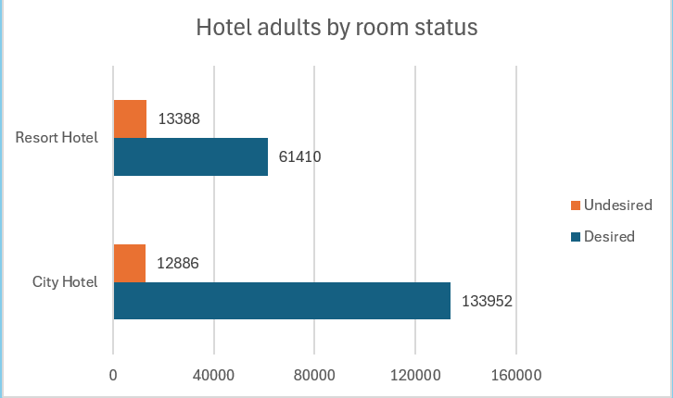

- Resort Hotel
  - Undesired Rooms: 13,388 adults
  - Desired Rooms: 61,410 adults
  - Satisfaction Ratio: $4.6$
- City Hotel
  - Undesired Rooms: 12,886 adults
  - Desired Rooms: 133,952 adults
  - Satisfaction Ratio: $10.4$

Key Insights
- City Hotels outperform Resort Hotels: City Hotels have a much higher proportion of adults in desired rooms, indicating better room allocation and guest satisfaction.
- Resort Hotels show weaker satisfaction: With a lower satisfaction ratio (4.6 vs 10.4), Resort Hotels may struggle with room assignment or availability.
- Operational Impact:
  - City Hotels likely benefit from efficient booking systems and higher inventory of preferred rooms.
  - Resort Hotels may face seasonal demand mismatches or limited room categories, leading to more undesired allocations.

  - Room Satisfaction KPI :
- City Hotel: 10.4
- Resort Hotel: 4.6

6.What is the impact of children/babies on booking confirmation vs cancellation?
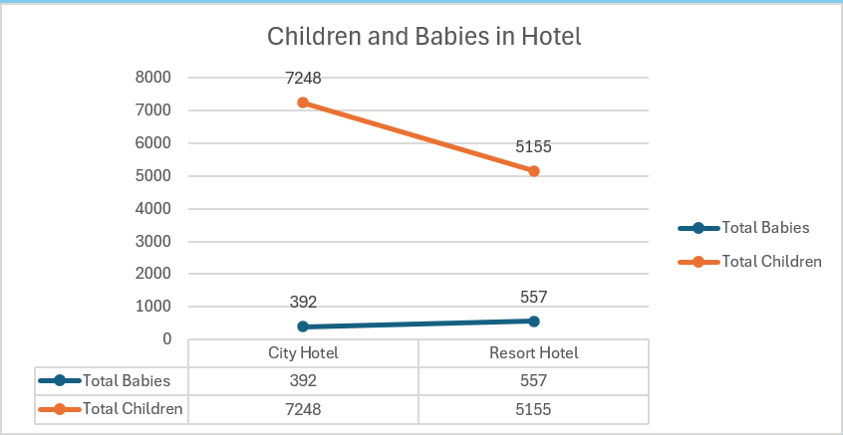
  - City Hotel
- Babies: 392
- Children: 7,248
  - Resort Hotel
- Babies: 557
- Children: 5,155

Key Insights
- City Hotels attract more children: With 7,248 children, City Hotels are more family-oriented for older kids.
- Resort Hotels host more babies: Resorts have 557 babies vs 392 in City Hotels, suggesting families with infants prefer leisure/resort stays.
- Overall demographic trend: Children numbers are significantly higher than babies in both hotel types, meaning family travel is dominated by school-age kids.
- Operational Impact:
  - City Hotels may need more child-friendly facilities (play areas, kids’ menus).
  - Resort Hotels should focus on baby amenities (cribs, baby food, medical support).

KPI
- Children-to-Babies Ratio KPI:
  - City Hotel: $18.5$ - 18 children per baby.
  - Resort Hotel: $9.3$ - 9 children per baby.

